Project-II Synopsis

on

SENTIMENT ANALYSIS OF FINANCIAL MARKET
Computer Science Engineering (Data Science)

Submitted by

TARANDEEP PLAHA

SAHIL BHUSARI

SOLOMON ALEXANDER

KAUSTUBH MATE

Under the guidance of

Prof. JAYSHRI HARDE
(Assistant Professor)

Academic Year 2024-25

Department of Computer Science Engineering
(Data Science)

ST. VINCENT PALLOTTI COLLEGE OF ENGINEERING AND TECHNOLOGY
Wardha Road, Gavsi Manapur, Nagpur

CONTENTS

1. Introduction
2. Objectives
3. Scope of the system
4. Literature Review
5. Proposed Methodology
6. Tools and Technologies
7. Expected Outcomes
8. Conclusion
9. References

1. Introduction
Domain Overview:
The domain of this project is sentiment analysis within financial markets, specifically focusing on stocks. Sentiment analysis is a natural language processing (NLP) technique that involves analyzing text data from sources like news articles, social media, and financial reports to gauge public sentiment. In the context of financial markets, sentiment analysis helps predict stock price movements by assessing the emotional tone of relevant text data.

Motivation:
The motivation behind choosing this project stems from the increasing influence of public sentiment on stock market behavior. Traditional financial analysis methods are often insufficient in predicting short-term market movements driven by news or social media trends. This project aims to bridge this gap by providing real-time sentiment insights, enhancing decision-making processes for investors and traders.

Significance and Importance:
The significance of this project lies in its potential to revolutionize how financial data is interpreted and utilized. By integrating real-time sentiment analysis with interactive data visualization, the system can offer users a more nuanced understanding of market dynamics. This innovation can lead to more informed investment strategies, reduced financial risk, and improved market transparency.

2. Objectives
The primary objectives of this project are:
- To develop a dynamic, interactive dashboard that displays real-time sentiment analysis of financial markets.
- To provide live updates every 5 seconds, ensuring data reflects the most current market conditions.
- To enhance the dashboard's user interface with attractive visuals and clear, concise data representation.
- To implement features like a clear button that resets the output when a new search query is initiated.
- To optimize the overall performance of the dashboard, making it a superior alternative to existing solutions.

3. Scope of the System
Boundaries:
The scope of this project includes developing a real-time dashboard that provides sentiment analysis insights for stocks based on news, social media, and financial reports. The system will focus on sentiment data acquisition, processing, visualization, and performance optimization.

4. Literature Review
The literature review explores existing research and applications of sentiment analysis in financial markets. Various studies highlight the efficacy of sentiment analysis in predicting stock prices and market trends. Research emphasizes the importance of integrating sentiment data into trading strategies to enhance decision-making processes.
For instance, Aggarwal and Wu (2006) discussed market manipulations and how sentiment data could offer predictive insights. Allen and Gale (1992) highlighted stock price manipulations, underscoring the importance of sentiment analysis in identifying such patterns. The review also examines statistical learning methods such as those outlined by Vapnik (1998), which form the foundation of modern sentiment analysis techniques.

5. Proposed Methodology
Overview:
The proposed methodology involves data collection, sentiment analysis, and data visualization to create an interactive dashboard.
Process Flow:
- Data Collection: Gather real-time data from sources like news, social media, and financial reports using APIs.
- Preprocessing: Clean and preprocess data by removing noise, standardizing formats, and extracting relevant text.
- Sentiment Analysis: Use machine learning models such as NLP-based algorithms to classify sentiment.
- Data Visualization: Present the analyzed data on a dynamic dashboard, updated every 5 seconds.
- User Interface Optimization: Integrate features like clear buttons to enhance usability.

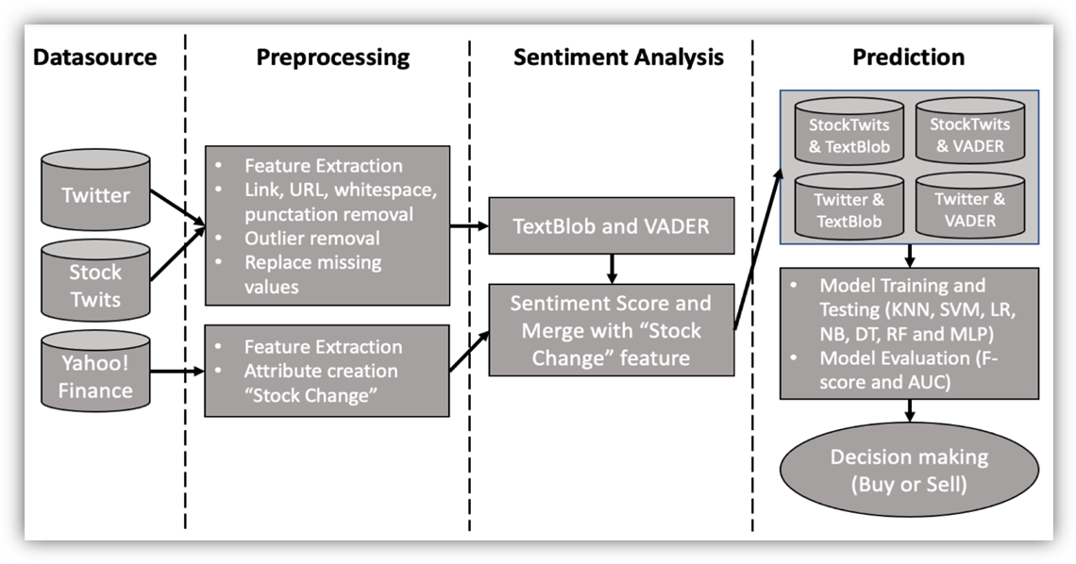

6. Tools and Technologies
Programming Languages: Python
Software: TensorFlow, VScode, Tableau, PowerBI
Hardware: Standard CPUs, GPUs for processing, RAM, storage drives, networking devices.

7. Expected Outcomes
The project aims to develop a sophisticated sentiment analysis system that predicts market movements accurately. The expected outcomes include:
- An efficient, real-time dashboard providing up-to-date sentiment insights.
- Improved investor decision-making with clear, dynamic data representations.
- An optimized user experience that surpasses current market tools.
- Greater market awareness and risk mitigation for users relying on sentiment data.

8. Conclusion
This project will significantly impact how investors and traders analyze market sentiment. By providing a dynamic, user-friendly, and real-time dashboard, it addresses current limitations in the financial analytics domain. Future enhancements could include expanding data sources, improving sentiment analysis accuracy, and incorporating predictive analytics for more comprehensive market forecasting.
Future Scope:
- Integration of additional data sources for a broader sentiment analysis.
- Machine learning enhancements to improve sentiment prediction accuracy.
- Development of mobile-friendly versions for on-the-go market analysis.

9. References
- Aggarwal, R., & Wu, G. (2006). Stock market manipulations. Journal of Business, 79(4), 1915–1954.
- Allen, F., & Gale, D. (1992). Stock price manipulation. Review of Financial Studies, 5(3), 503–529.
- Vapnik, V. (1998). Statistical learning theory (1st ed.). New York, NY: Springer.

Roll No . Name of the Student Signature

12. Sahil Bhusari

16. Solomon Alexander

57. Kaustubh Mate

61. Tarandeep Plaha

Date :
--------------------------------------------------------------------------------------------------------------
Name of the guide :
Signature with date :

Remarks :

--------------------------------------------------------------------------------------------------------------
Sign of HOD : Date:

Remarks :

